Configuring TXT on Xen/Ubuntu Server for RP
- Contents
2 References 2
3 BIOS Settings for Dell Romley Server 2
4 How to check the TXT/TPM status in Linux Distributions 8
5 Tboot Installation 10
6 Grub Configuration 11
7 TCG software Stack installation 13
8 Installing RP Components 13
8.1 Untar of RP Components 13
7.1.1 Core Services (rpcoreservice) 13
8.1.2 RP KSS(Key Signing Server) 14
7.2 Configuring RP keys 14
7.2.1 Generating Policy Key 14
7.2.2 Generating AIK 16
7.2.3 Signing AIK Key with Policy Key 16
7.2.4 Creating/Updating configuration file 16
7.2.5 Xen Domain Network Configuration 17
7.2.6 DomU Configuration 17
7.2.7 Script for Creating RAMDISK File for kns/srv/cli doms. 18
7.2.8 Generate dom0 TrustedOS keys and certs. 19
7.3 Running the RP Core Service 19
7.4 Creating and running untrusted VM: DomU 19
7.5 Start measured VM 20
7.6 Test the DomU setup 20
7.7 Test the DomDT(srv) setup 20
7.8 Test the KSS setup 20
7.9 Installing RP Crypto library 20
9 Running setup validation with domtest app for seal/unseal, attest, etc. 21

References

- TXT/TPM Activation Instruction for Romley Platforms, by Kamal Natesan
- TXT Provisioning Guide OS: Ubuntu 11.10 VMM: XEN, by Kamal Natesan

BIOS Settings for Dell Romley Server

Key Takeaways
▪ DELL ships the server with both BIOS and uEFI mode
▪ DELL ships SINIT ACM as part of BIOS/uEFI
▪ TXT launch was successful both in uEFI and BIOS mode.

Out of the Box configuration
- Press F2 to enter in to BIOS console

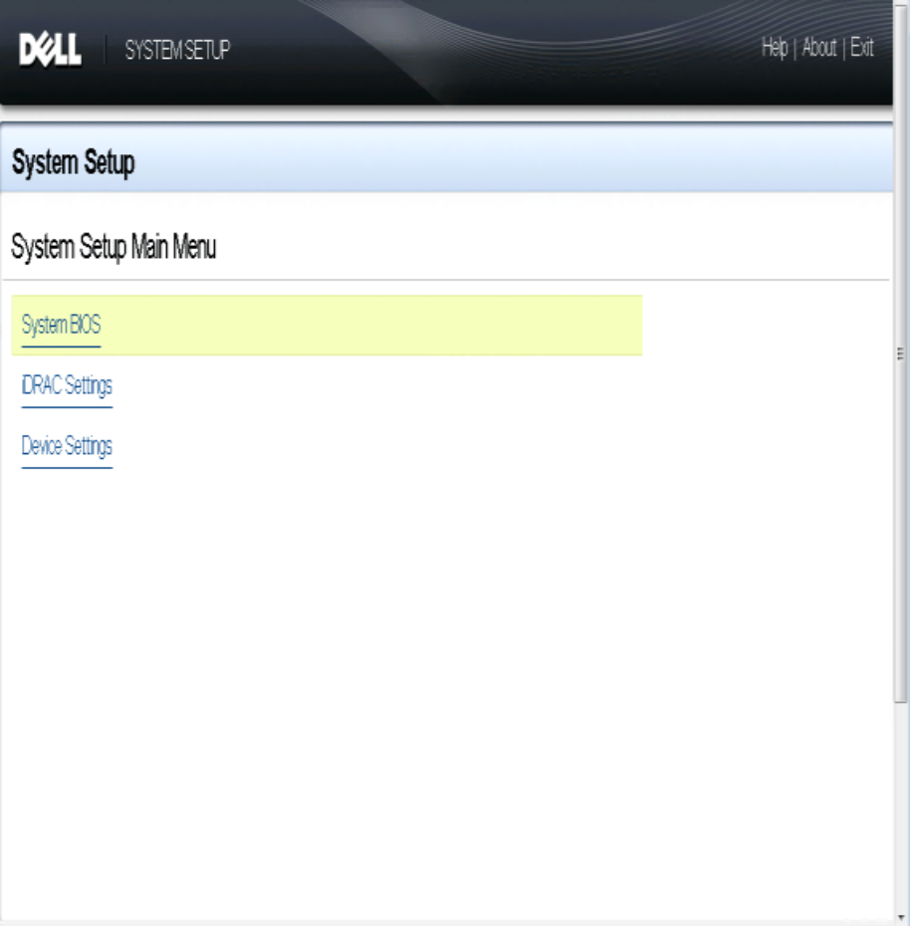
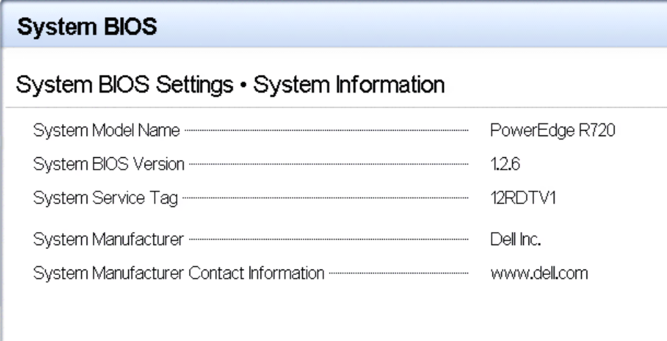

2."Ensure to verify VT is enabled Click on ""BIOS Settings"" > Processor Settings "

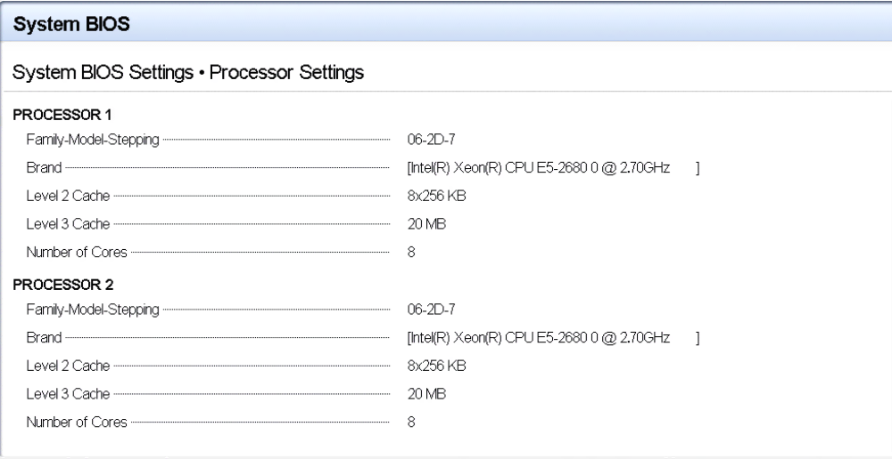

3. "Setup BIOS password: System BIOS Settings > System Security > Setup Password

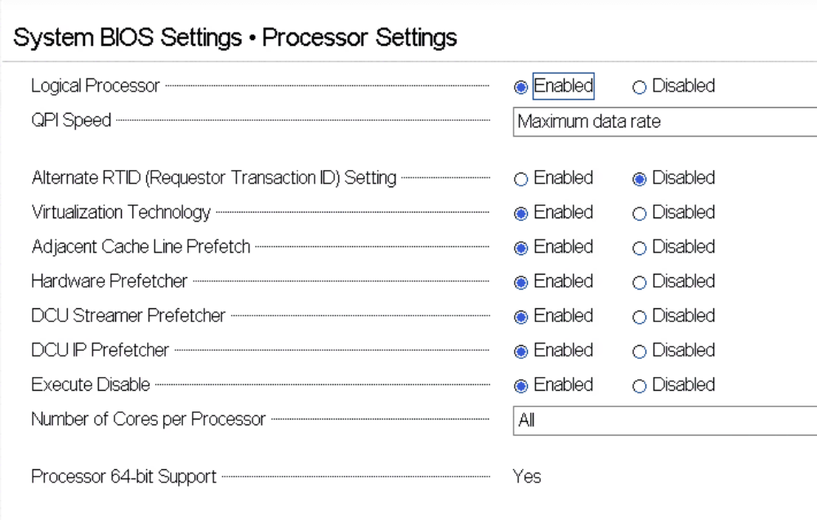

System BIOS Settings > System Security > Password Status > Locked System BIOS Settings > System
Security > On with Preboot Measurement System

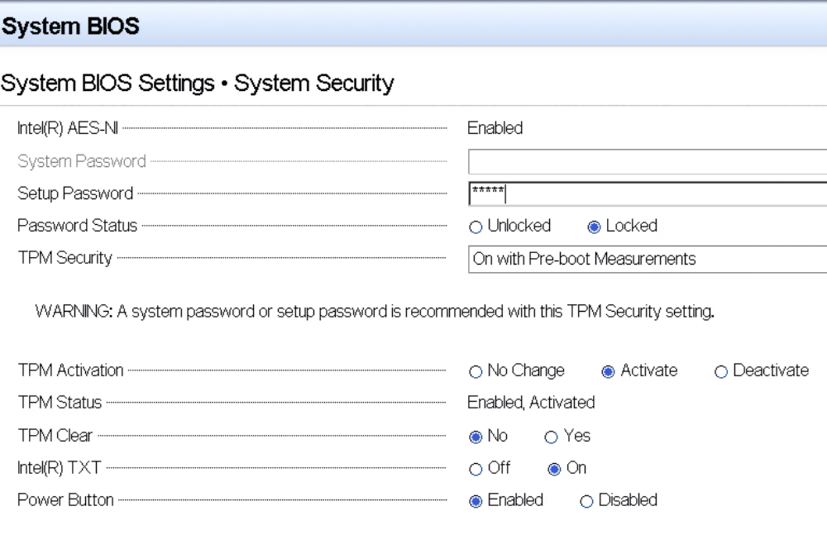

BIOS Settings > System Security > TPM Activation > ActivateSystem BIOS Settings > System Security > Intel TXT > On"
6. Press "Esc" key and click on "yes" to save the changes.
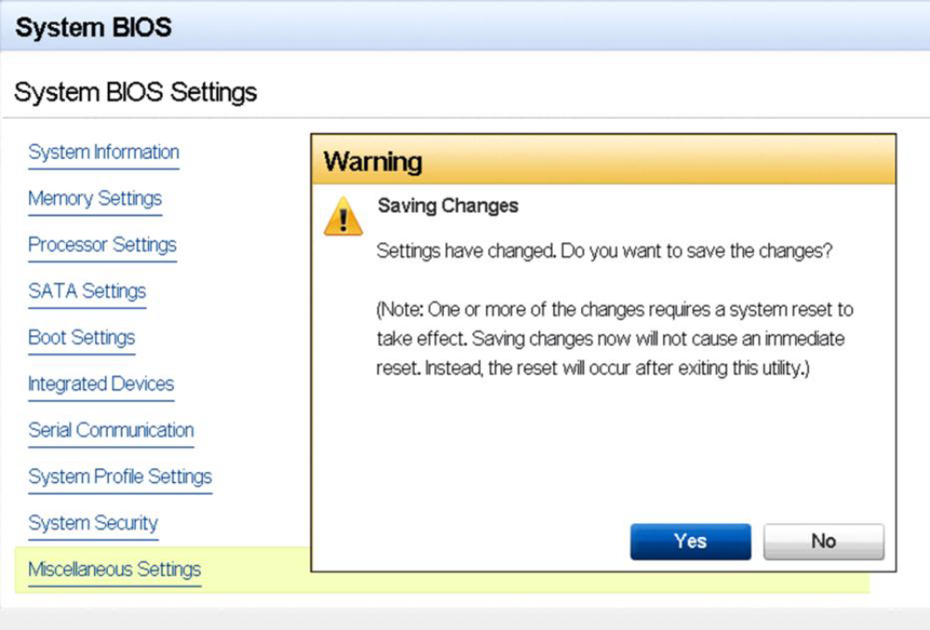
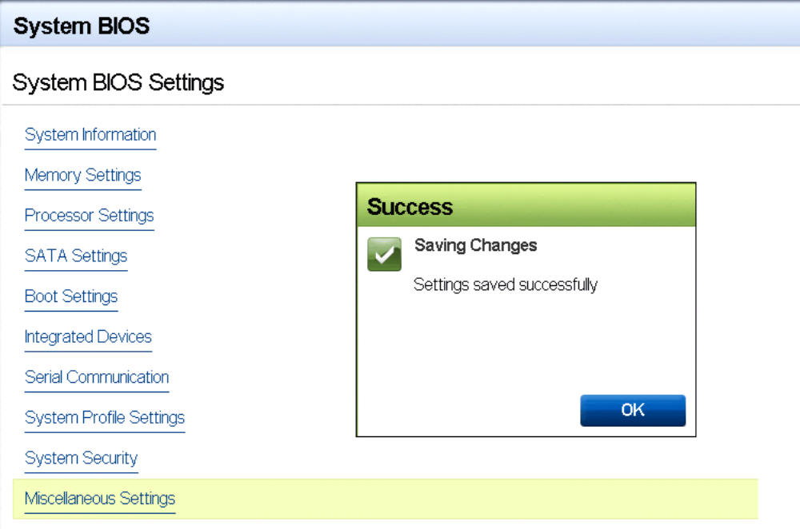

7. System BIOS Settings > Boot Settings > Boot Mode > BIOS
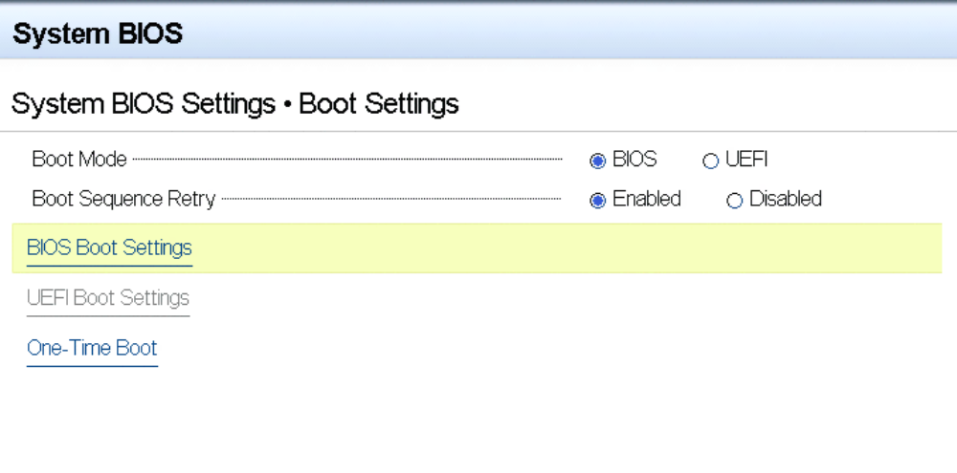
TPM Clear and Reactivate TXT/TPM

TPM clear can be done either in BIOS/uEFI console or from OS using Trousers DLL. One of the requirements for TPM clear is to transfer the TPM ownership. TPM clear action will deactivate the TPM. So reboot is required to activate the TPM/TXT again in the server

Below are the steps to clear the TPM in BIOS/uEFI console.
1. Press F2 to enter in to BIOS console [it will prompt for BIOS password entry]
2. BIOS Settings > System Security > TPM Activation > Activate System BIOS Settings > System Security > TPM clear > On"

Press "Esc" key and click on "yes" to save the changes.
4. Press F2 to enter in to BIOS console
5. "Ensure to verify VT is enabled Click on ""BIOS Settings"" > Processor Settings”
6. System BIOS Settings > System Security > Password Status > LockedSystem BIOS Settings > System Security > On with Preboot MeasurementSystem

7. BIOS Settings > System Security > TPM Activation > ActivateSystem BIOS Settings > System Security > Intel TXT > On"
8. Press "Esc" key and click on "yes" to save the changes.
9. System BIOS Settings > Boot Settings > Boot Mode > BIOS
10. Esc > save settings > boot the server

How to check the TXT/TPM status in Linux Distributions
Assumption:
Users have successfully activated TXT in BIOS and OS by following the respective guides.
To Activate the TXT in Linux OS users are requested to follow the TXT OS Setup Guide.

- TPM Status Can be read from linux OS through TPM Device Driver in Dom0.
- Issue below command to find the status of the TPM

$ cat /sys/class/misc/tpm0/device/enabled
# If it returns 0 then it is not enabled; if it returns 1 then it is enabled.
$ cat /sys/class/misc/tpm0/device/active
# If it returns o then it is not active; if it is returns 1 then it is active.
$ cat /sys/class/misc/tpm0/device/owned
# If it returns o then it is not owned; if it is returns 1 then it is owned.
$ cat /sys/class/misc/tpm0/device/pcrs
# Returns the PCR measurement values.
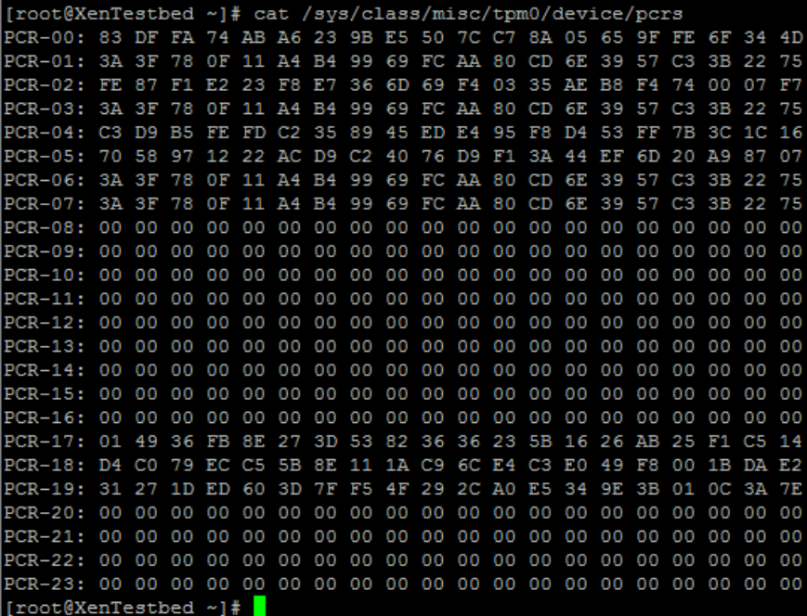
“Txt-stat” Tool:
▪ txt-stat is the TXT status tool that is part of Tboot kernel to get the status of TXT measurement.txt-stat tool collects the information from RAM and displays.
▪ Users can use this tool to check if the TXT launch/boot was successful or not.
▪ Ensure to run tcsd daemon before running this tool.

$ tcsd
$ txt-stat | more
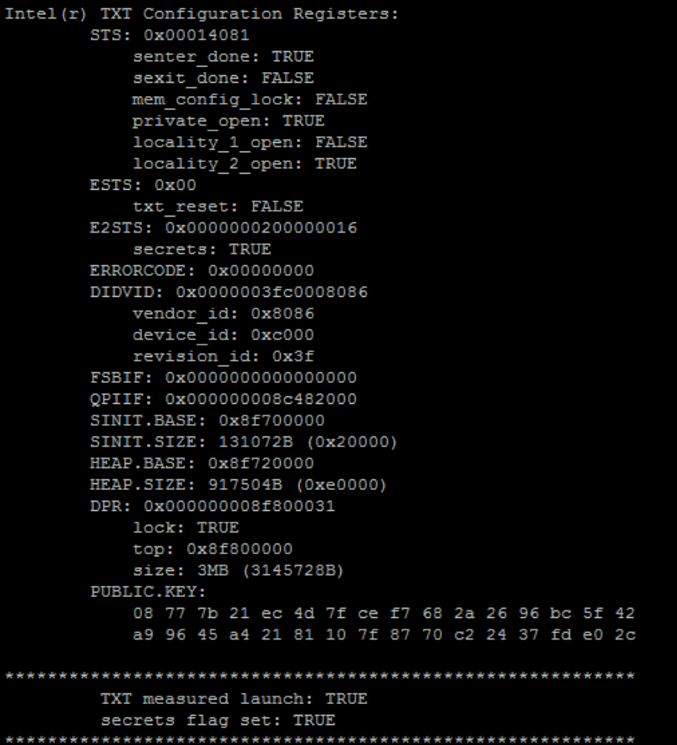

Tboot Installation

$ reboot
1.1 Tboot installation
1. Login as root user and install tboot.

$ apt-get install tboot
Note: Tboot.gz will be loaded in /boot

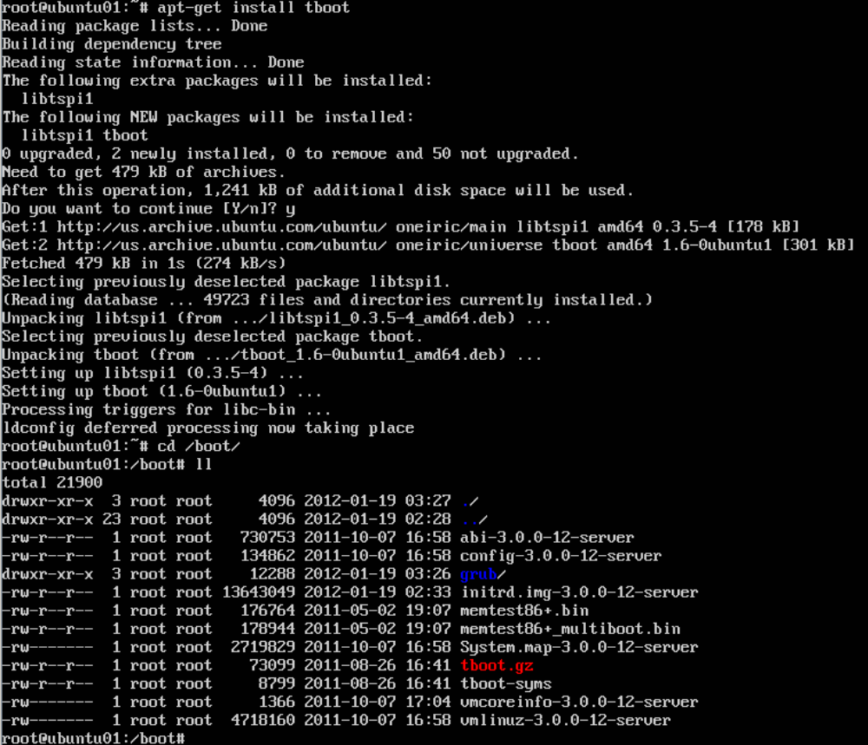
Note on SINIT: Note: For Romley Based servers the SINIT ACM is part of BIOS itself. So additional SINIT download and configuration is not required for Intel E5xxx based processors. (From discussion with Kamal same for 26XX)

Grub Configuration

Modify grub config to include entry..
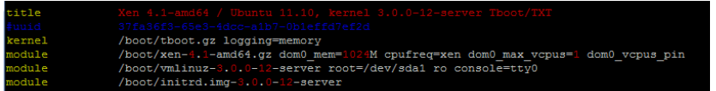

Reboot the server and login as root user.

Upon rebooting, a boot menu will be displayed allowing the user to select which environment to boot to. Select the first option to boot with TXT/tboot.

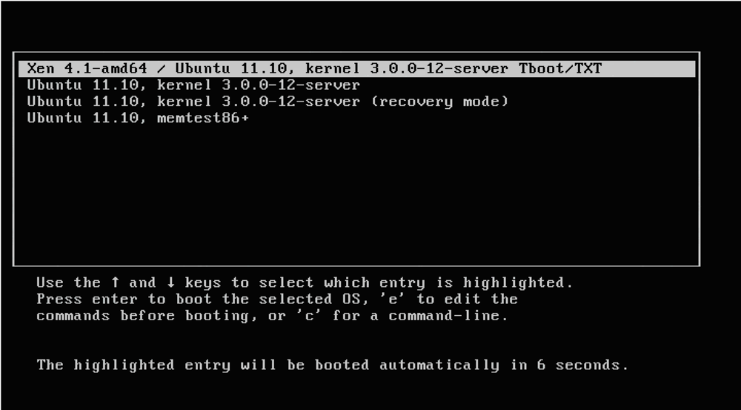

PCR 17-19 should now appear populated when queried using the below command:
$ cat /sys/class/misc/tpm0/device/pcrs
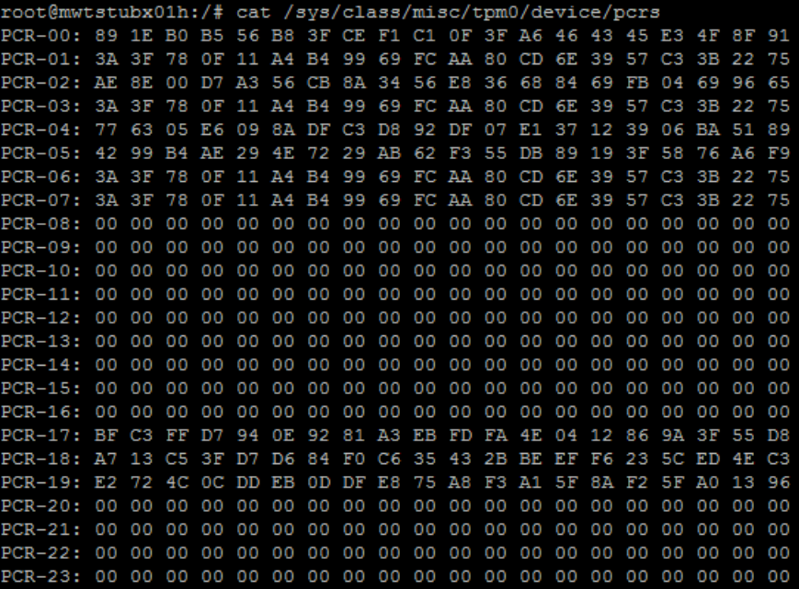

TCG software Stack installation
This Step is required to configure TPM. It is one time process and not required during run time.

- Login as root user and install trousers
- install trousers
- sudo agt-get install trousers
- sudo agt-get install tpm-dev
- sudo agt-get install tpm-tools
- sudo agt-get install libtspi-dev

- Run the TCSD daemon in the background.
- sudo bash
- tscd start
- tpm_takeownership -z -y
- tpm_getpubek

Note: If someone has already taken ownership, you must disable the tpm and reenable it.

Installing RP Components

Untar of RP Components

7.1.1 Core Services (rpcoreservice)
Untar(tar -xvf <tar file>) the RP Platform Services tar bundle into a directory of your choice($ROOT). The package will be installed there and will have the following directory structure and contents:
$ROOT
└── rp
├── bin
│ ├── kss ... Key signing server program. Separately packaged also(RPkss Package).
│ └── rpcoreservice ... This is the RP core services server program
│ └── domtest ... This is DomDT(srv) launcher.(See srv_start.sh/cli_start.sh scripts also)
│ └── rptest ... This is DomDT(srv) rptrust tester.
├── config ... These are config files
│ ├── HW
│ ├── HWRoot
│ ├── policy
│ ├── tcconfig.xml
│ └── TrustedOS
├── domimages
│ ├── 3.7.1 ----- This directory is for the RAMDISK
│ │ ├── ...
│ │ ├── ...
│ │ ├── ...
│ │ ├── ...
│ │
├── src ..... This dir is for source code if any
└── xen
└── kns ...... This is basically DomU

Files:
- Directories in red color will be created during key configuration step.

RP KSS(Key Signing Server)
Untar(tar -xvf <tar file>) the RP Platform Services tar bundle into a directory of your choice($ROOT). The package will be installed there and will have the following directory structure and contents:
$ROOT
└── rp
├── bin
│ ├── kss ... This is the key signing server program
│ ├── vTCI ... This is a tool to make the AIK Key
│ ├── signerutil ... This is for producing the AIK Certificate
├── config ... These are config files
│ ├── policy
│ │ └── privatePolicyKey.xml ...Signing Key
│ ├── tcconfig.xml ...Config file
└── RPkssReleaseNotes.txt ...KSS Release Notes

7.2 Configuring RP keys
This section describes the following:
- Generating policy key
- Generating AIK
- Signing AIK
- Creating/Updating configuration file
- Running rpcoreservice –initkeys

Assumption: you are logged in as root

7.2.1 Generating Policy Key
policyKey is a private key of VM owner and should be on different machine running KSS. You should NEVER have the private key on an insecure computer and you should NEVER lose this key.

For version 1.0 we are running from dom0 of the server.This key will be created onto the KSS Computer later.

In case, config directory exists, take a backup of the current config directory.
- Create $(ROOT)/rp/config directory
- cd $(ROOT)/rp/config
- Generate a public/private key pair (the "activity policy key").
- mkdir policy
- cd policy
- $(ROOT)/rp/bin/signerutil -GenKey RSA1024 policyPrivateKey.xml
  - (If you already have this key, copy into the policy directory and no need to create a new one)

7.2.2 Generating AIK
Note: If someone has already taken ownership, you must disable the tpm and reenable it. You may have to remove power to reset the TPM and you may have to create an endorsement key using tpm_createek command
Otherwise,
  - cd $(ROOT)/rp/config
  - mkdir HW
  - $(ROOT)/rp /bin/vTCI -initAIK

This command puts the generated AIK Blob file in the subdirectory $(ROOT)/rp/config/HW/aikblob and aikKeyFile.

  - mkdir $(ROOT)/rp/config/HWRoot
  - cp $(ROOT)/rp/config/HW/aikblob $(ROOT)/rp/config/HWRoot/aikcreds
  - cp $(ROOT)/rp/config/HW/aikblob $(ROOT)/rp/config/HWRoot/privatekey

Convert binary aikKeyFile to ascii hex formatted aikhexmod.txt file using the following command

xxd -ps -c 32 $(ROOT)/rp/config/HW/aikKeyFile > $(ROOT)/rp/config/HWRoot/aikhexmod.txt

7.2.3 Signing AIK Key with Policy Key
- $(ROOT)/rp/bin/signerutil -SignHexModulus $(ROOT)/rp/config/policy/policyPrivateKey.xml $(ROOT)/rp/config/HWRoot/aikhexmod.txt $(ROOT)/rp/config/HWRoot/cert

7.2.4 Creating/Updating configuration file
- cd $(ROOT)/rp/config
- create a file tcconfig.xml with the following parameters:
Parameter | Description/Desired value
directory | This is the root directory for rpcorservice and kss.
signing_server_ip | This is the ip address of the KSS. In version 1.0, it is the same as the rpcore_ip.
signing_server_port | This is the tcp port for KSS.
rpcore_ip | This is the ip address for rpcoreservice. This is same as the ip address of dom0.
rpcore_port | This is the tcp port for rpcoreservice.
cert_domain | The value of this parameter should be kept as www.manferdelli.com
vif_br_script | The value of this parameter should be kept as  /etc/xen/scripts/vif-bridge
default_console | The value of this parameter should be console=hvc0
- A sample example tcconfig file is as follows. Assumes that 192.168.1.2 is the addres assigned to the Host Server(Dom0):
<tc_config>
<directory> /home/s1/rp/config </directory>
<signing_server_ip> 192.168.1.3 </signing_server_ip>
<signing_server_port> 6001</signing_server_port>
<rpcore_ip> 192.168.1.3 </rpcore_ip>
<rpcore_port> 6005</rpcore_port>
<cert_domain>www.manferdelli.com</cert_domain>
<vif_br_script>/etc/xen/scripts/vif-bridge</vif_br_script>
<default_console>console=hvc0</default_console>
</tc_config>
Xen domain networking configuration:

7.2.5 Xen Domain Network Configuration
  - mv /etc/network/interfaces /etc/network/interfaces.ori
  - create a file /etc/network/interfaces as follows:

auto lo
iface lo inet loopback

auto xenbr0
iface xenbr0 inet static
address 192.168.1.3
broadcast 192.168.1.255
netmask 255.255.255.0
gateway 192.168.1.1
bridge_ports eth0
bridge_stp no
bridge_fd 2

auto eth0
iface eth0 inet manual

7.2.6 DomU Configuration
- Create a /etc/xen/domU file. It is assumed that Host IP address(dom0) is 192.168.1.3 and 192.168.1.7 will be the IP address of the domU VM.
- A sample minimum domU config file is as follows:
name = "kns"
memory = 64
vcpus = 1
#
kernel = "/home/s1/BOOTDU/vmlinuz-3.7.1-dU"
ramdisk = "/home/s1/rp/domimages/kns.igz"
extra = "rpdomid=100 rpcoreip=192.168.1.3 ipaddr=192.168.1.7 console=hvc0"
on_poweroff = "destroy"
on_reboot = "restart"
on_crash = "restart"
#
vif = [ "bridge=xenbr0, ip=192.168.1.3" ]

7.2.7 Script for Creating RAMDISK File for kns/srv/cli doms.
- cd $(ROOT)/rp/domimages
- create the following mkirfs.sh with the following contents(the text in red must be changed).:

cp ../bin/rptest ./3.7.1/bin

echo "building cinit"
cd ./3.7.1
cp ../cinit init
find . | cpio -H newc -o > ../initramfs.cpio
cd ..
cat initramfs.cpio | gzip > cli.igz

echo "building sinit"
cd ./3.7.1
cp ../sinit init
find . | cpio -H newc -o > ../initramfs.cpio
cd ..
cat initramfs.cpio | gzip > srv.igz
echo "building domstart"
cd ./3.7.1
cp ../kinit init
echo "domtest -name srv -memory 64 -bridge xenbr0 -kernel /home/s1/BOOTDU/vmlinuz-3.7.1-dU -ramdisk /home/s1/rp/domimages/srv.igz -ipaddr 192.168.1.5" > srv_start.sh

echo "domtest -name cli -memory 64 -bridge xenbr0 -kernel /home/s1/BOOTDU/vmlinuz-3.7.1-dU -ramdisk /home/s1/rp/domimages/cli.igz -ipaddr 192.168.1.6" > cli_start.sh
chmod +x *_start.sh

cp ../../bin/domtest ./bin

find . | cpio -H newc -o > ../initramfs.cpio
rm ./bin/domtest

cd ..
cat initramfs.cpio | gzip > kns.igz
rm initramfs.cpio
echo "done"

- execute the mkirfs.sh script. This also creates the srv_start.sh script which will be used to launch the srv Dom.

7.2.8 Generate dom0 TrustedOS keys and certs.
In separate terminal window in dom0
  - cd $(ROOT)/rp/config
  - Run $(ROOT)/rp/bin/kss

In another terminal window in dom0
  - sudo bash
  - cd $(ROOT)/rp/config
  - Run $(ROOT)/rp/bin rpcoreservce –initKeys

Verify that TrustedOS directory is populated. In case it is empty, refer to tcService.log and KeyNegoserver.log files under $(ROOT)/rp/config.

Take secure backup of $(ROOT)/rp/config directory.

Note: 1. Once keys are initialized, KSS service need not be running.
2. In a future version, KSS would run on a separate secured Linux Box.

7.3 Running the RP Core Service
  - Boot System into Xen Mode with TBOOT security enabled
  - In a terminal window,
    - Sudo bash
    - Stop trousers if running.
    - cd $(ROOT)/rp/config
    - $(ROOT)/rp/bin/rpcoreservice
- Verify that there are no errors on the terminal as well as intcService.log.

7.4 Creating and running untrusted VM: DomU
  - Untrusted VM creation
  - In a terminal window,
    - sudo bash
    - Start the xencommons services
    - xl create /etc/xen/domu

7.5 Start measured VM
  - sudo bash
  - xl console domu - This will give you a console to kns.
  - To start measured VM named srv, run the srv_start.sh script (You can directly use domtest also).
- This will launch the srv domain.
  - Exit the domu console by pressing CTRL + ]
  - xl list - The DomDT(srv) vm should be there.
  - xl con srv - This will give you a console to srv DOM
- - rptest - This will test service accessibility from dom0.
- There will be some XML structures printed on the DomDT(srv) console
- if things are OK.

7.6 Test the DomU setup
- xl list(Dom0) should show kns listed as a VM. And do "xl con kns"
to get on to it from Dom0.

7.7 Test the DomDT(srv) setup

7.8 Test the KSS setup
- Run kss and then run rpcoreservice with -initKeys option on Dom0.
This should successfully finish. Check the TrustedOS directory on
Dom0 is not empty.

7.9 Installing RP Crypto library
Untar(tar -xvf <tar file>) the RP Crypto library into a directory of your choice($ROOT). The rp library will be installed there and will have the following directory structure and contents:

$ROOT
└── rp
├── examples
│ ├── PlainText1
│ ├── rpapisample1.cpp
│ └── rpapisample1.h
├── inc
│ └── rpapi.h
├── lib
│ └── librpcrypto.a
├── ReleaseNotes.txt
└── RPapidoc.txt

Files:
- librpcrypto.a : This is the RP Crypto library which needs to be linked to the program using RP Crypto functioanlity.
- rpapi.h : The .h file that needs to be included by a RP Crypto based program/modules.
- ReleaseNotes.txt: This file containing the updated release notes.
- rpapidoc.txt : Contains some documentation about the APIs.
- rpapisample.cpp,rpapisample.h: A sample program using the RP Crypto APIs.
- PlainText1: A plaintext file used by the sample program.

Compilation and Execution of the Sample Program:
After untarring the RP Crypto library into the $ROOT directory, cd to rp/examples directory where you will find the sample program(s). Issue the following command(s) at the terminal:

g++ rpapisample1.cpp -I../inc -o rpapisample1 -L../lib -lrpcrypto

Execute the program by entering the following at the shell prompt:
./rpapisample1

Note: This is only needed on machines where development based on this library is done.

Running setup validation with domtest app for seal/unseal, attest, etc.
This section explains the steps for creating the srv Dom(DTapp) using domtest and will test the seal/unseal/attest example:
- xl con kns - This will give you a console to kns.
- Run the srv_start.sh script(You can directly use domtest also).
This will launch the srv domain.
- Exit the kns console by pressing CTRL + ]
- xl list - The DomDT(srv) vm should be there.
- xl con srv - This will give you a console to srv DOM
- rptest - This will test service accessibility from dom0.
There will be some XML structures printed on the DomDT(srv) console
if things are OK.

